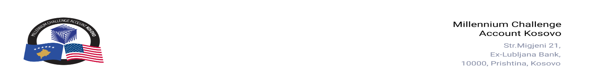

CONTRACT AWARD NOTICE

Country | : | Kosovo
City/Locality | : | Prishtina
Funding Agency | : | Millennium Challenge Corporation
Buyer | : | Millennium Challenge Account – Kosovo
Period | : | June, 2026

In accordance with the MCC Accountable Entity Procurement Policy and Guidelines, MCA-Kosovo publishes contract award notices to promote transparency. These notices are published at least monthly on the Accountable Entity website and cover all contracts signed within the preceding 30 days, including awards made through Limited Bidding, Direct Contracting, and Sole Source Selection.
The following contracts were awarded during the period of June 2026.

Goods and Non-Consultant Services
Number | Name of the Procurement | Selected Offeror | Contract Amount | Contract Period | Scope of the Contract
26-1005 | Supply and Installation of Air conditioning Units for MCA-Kosovo office | Multi Solutions L.L.C. | EUR 3,700.00  (Three Thousand Seven Hundred Euros) | Contract signed on: June 01, 2026  Delivery: Seven (7) calendar days from the date of contract signature. | Supply, delivery, and installation of Air conditioning units for the MCA-Kosovo Office with a warranty period of 24 months.
26-1007 | Glass Doors Visibility Markings for MCA-Kosovo Office Safety & Security | TRG L.L.C. | EUR 1,260.00  (One Thousand Two Hundred and Sixty Euros) | Contract signed on: June 15, 2026  Delivery: Fifteen (15) days from the date of signing the Purchase Order. | Supply, delivery, and installation of the Glass Door Visibility Markings.
26-3002(e) | Renting of conference rooms & ancillary services | Sami R. Ahmeti B.I.  N.H.T “Sirius” - B | Blanket Purchase Agreements (BPA) | BPA signed on: June 24, 2026.  BPA duration: One year from the signature date, with option to extend for additional periods. | Renting conference rooms & ancillary services for MCA-Kosovo activities.
26-3003 | Preventive Maintenance of Equipment in MCA-Kosovo Server Room | InterAdria L.L.C. | EUR 40,500.00  (Forty Thousand Five Hundred Euros) | Contract signed on: June 25, 2026.  Contract duration: Base Period (6 months) with up to three (3) option periods (12 months each), exercisable at MCA-Kosovo’s sole discretion. | Preventive and corrective maintenance services for MCA-Kosovo Server Room equipment, including air-conditioning units and other equipment.

Note: Blanket Purchase Agreements (BPAs) are agreements to enter into contracts, not contracts themselves. A contract is formed only when an order is placed; therefore, neither party is bound until that point.

