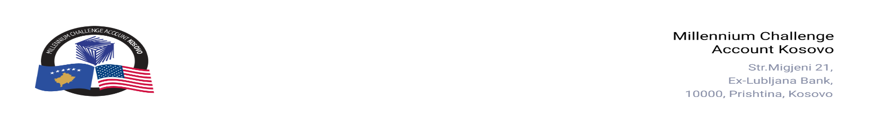

CONTRACT AWARD NOTICE

Country | : | Kosovo
City/Locality | : | Prishtina
Funding Agency | : | Millennium Challenge Corporation
Buyer | : | Millennium Challenge Account – Kosovo
Period | : | April–May 2026

In line with the MCC Accountable Entity Procurement Policy and Guidelines, MCA-Kosovo publishes contract award notices to ensure transparency. Notices are posted at least monthly on the Accountable Entity website and include all contracts signed within the previous 30 days, including those awarded through Limited Bidding, Direct Contracting, and Sole Source Selection.
The following contracts were awarded during the period of April–May 2026.

Goods and Non-Consultant Services
Number and Name of the Procurement | Selected Offeror | Contract Amount | Contract Period | Scope of the Contract
26-1004  Satellite-Based Broadband Internet Terminal System | Gjirafa, Inc – Branch in Kosovo | EUR 505.51  (Five Hundred Five Euros and Fifty-One Cents) | Purchase Order signed: May 08, 2026  Delivery: Twenty (20) days from the date of signing the Purchase Order. | Supply, delivery, and installation of a satellite-based broadband internet terminal system.
26-1002  Microclimate and electrical measuring devices for MCA-Kosovo’s Offices | Loging Electronics-Kosova L.L.C. | EUR 6,036.80  (Six Thousand Thirty-Six and Eighty cents) | Contract signed on: April 16, 2026  Delivery: Ninety (90) days from the date of the contract signature | Supply and delivery of microclimate and electrical measuring devices for MCA-Kosovo's offices.
26-1006  Picture Frames for MCA Kosovo Office | TRG L.L.C. | EUR 752.50  (Seven Hundred Fifty-Two Euros and Fifty Cents) | Purchase Order signed: May 28, 2026  Delivery: Five (5) days from the date of signing the Purchase Order. | Supply and delivery of picture frames for the MCA-Kosovo Office
26-3002a  Renting of conference rooms & ancillary services | Hotel Astoria – Gjilan | Blanket Purchase Agreements (BPA) | BPA signed on: May 8, 2026.  BPA duration: One year from the signature date, with option to extend for additional periods. | Renting conference rooms & ancillary services for MCA-Kosovo activities.
26-3002b  Renting of conference rooms & ancillary services | Hotel Sharri - Prizren | Blanket Purchase Agreements (BPA) | BPA signed on: May 8, 2026.  BPA duration: One year from the signature date, with option to extend for additional periods. | Renting conference rooms & ancillary services for MCA-Kosovo activities.
26-3002c  Renting of conference rooms & ancillary services | N.H.T.SH “Shkelqimi – 2” L.L.C | Blanket Purchase Agreements (BPA) | BPA signed on: May 8, 2026.  BPA duration: One year from the signature date, with option to extend for additional periods. | Renting conference rooms & ancillary services for MCA-Kosovo activities.
26-3002d  Renting of conference rooms & ancillary services | Hotel Swiss Diamond - Prishtine | Blanket Purchase Agreements (BPA) | BPA signed on: May 13, 2026.  BPA duration: One year from the signature date, with option to extend for additional periods. | Renting conference rooms & ancillary services for MCA-Kosovo activities.
Note: Blanket Purchase Agreements (BPAs) are not contracts but agreements to contract. The contract occurs when an order is placed. Thus, there are no binding terms on either party.

