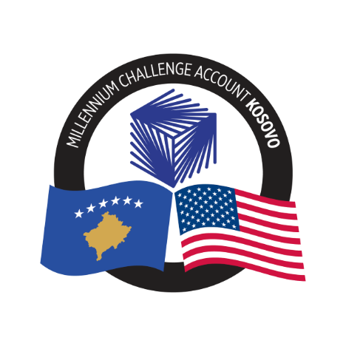
SPECIFIC PROCUREMENT NOTICE (SPN)

Country | Republic of Kosovo
Project Name | Program Administration
Procurement Title | Preventive Maintenance of Equipment in MCA-Kosovo Server Room
Procurement Ref. Number | 26-3003
Type of Procurement | Shopping
Accountable Entity | MCA-Kosovo
Publication Date | May 5, 2026
Submission Deadline | May 18, 2026, 03:00 PM (CET)

The Government of the Republic of Kosovo (the “Government” or “GoK”) and the Millennium Challenge Corporation (“MCC”), a United States government agency, signed a grant aimed at poverty reduction through economic growth in Kosovo on July 15, 2022, in the amount of US $202,000,000 (the “Compact”) and a corresponding contribution from the Government of approximately US $34,670,600 for Preventive Maintenance of equipment in MCA-Kosovo Server Room.
MCC’s funding is appropriated by the U.S. Congress and obligated to the compact up-front, with no incremental or partial funding. So, when a contract is signed with an Accountable Entity, money is already available to the Accountable Entity and, for most contracts, invoices are paid directly to Offerors by the US Treasury.
The procurement will be conducted through the Shopping procedures as specified in the Accountable Entity Procurement Policy & Guidelines effective January 8, 2025 (Version 1109.09). MCA-Kosovo hereby invites all eligible offerors to submit their Offers for Preventive Maintenance of equipment in MCA-Kosovo Server Room.
A complete set of bidding documents may be obtained by interested eligible offerors upon the completion of the registration form at: https://forms.office.com/r/QSFJ3LMX3C

Offers must be delivered electronically on or before May 18, 2026, at 03:00 PM (CET), in accordance with the RFQ. Late submissions will be rejected. Please note that only electronic offers shall be accepted.
Contact Information:
The address(es) referred to above is (are): | MCA–Kosovo  Migjeni Str. No. 21, 10000 Pristina, Republic of Kosovo
Attn: | MCA Kosovo  Procurement Agent
E-mail: | MCAKosovoPA@dt-global.com
Website: | www.mcakosovo.org

