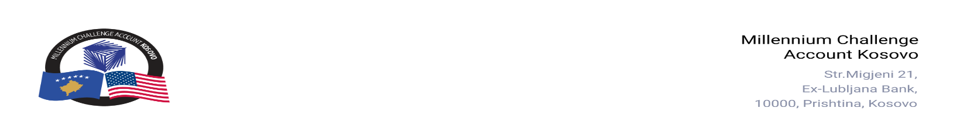

CONTRACT AWARD NOTICE

Country | : | Kosovo
City/Locality | : | Prishtina
Funding Agency | : | Millennium Challenge Corporation
Buyer | : | Millennium Challenge Account – Kosovo
Period | : | December, 2025

In line with the MCC Accountable Entity Procurement Policy and Guidelines, MCA-Kosovo publishes contract award notices to ensure transparency. Notices are posted at least monthly on the Accountable Entity website and include all contracts signed within the previous 30 days, including those awarded through Limited Bidding, Direct Contracting, and Sole Source Selection.
The following contracts were awarded during the period of December 2025:

Goods and Non-Consultant Services
Number and Name of the Procurement | Selected Offeror | Contract Amount | Contract Period | Scope of the Contract
25-1008  IT Equipment | STORM ICT L.L.C. | Blanket Purchase Agreement (BPA) | From December 26, 2025, up to 12 months with automatic extension for successive one-year periods until April 28, 2029. | Supply and delivery of IT equipment in accordance with the technical specifications.
25-3009(a)  Translation Services | Professional Language Center “Lingua”. | Blanket Purchase Agreement (BPA) | From December 05, 2025, up to 12 months. Renewable for up to three additional one-year periods (ending no later than April 30, 2029). | Translation Services for MCA-Kosovo.
25-3009(b)  Translation Services | AB & Associates L.L.C | Blanket Purchase Agreement (BPA) | From December 05, 2025, up to 12 months. Renewable for up to three additional one-year periods (ending no later than April 30, 2029). | Translation Services for MCA-Kosovo.
25-1003  Supply of personal protection equipment for MCA-Kosovo Staff and KOSTT PIU | N.P.T.” Bajra” | Blanket Purchase Agreement (BPA) | From December 03, 2025, up to April 28, 2029. | Supply of personal protection equipment for MCA-Kosovo Staff and KOSTT PIU
25-1004  Fire safety measures for MCA Kosovo office | Tekniku. L.L.C. | EUR 4,312.00 (Four Thousand Three Hundred Twelve EURO) | From December 11, 2025, to March 29, 2029. | Supply of equipment and tools, installation, training and maintenance of Fire safety equipment for MCA Kosovo office.
25-1007  Office Drawers | Galanteria SH.P.K. | EUR 4,440.00 (Four Thousand Four Hundred Forty Euros) | From December 2, 2025  Delivery: Thirty (30) calendar days from the date of signing the Purchase Order. | Supply, delivery, and assembly of movable office drawers.

Note: Blanket Purchase Agreements (BPAs) are not contracts but agreements to contract. The contract occurs when an order is placed. Thus, there are no binding terms on either party.

