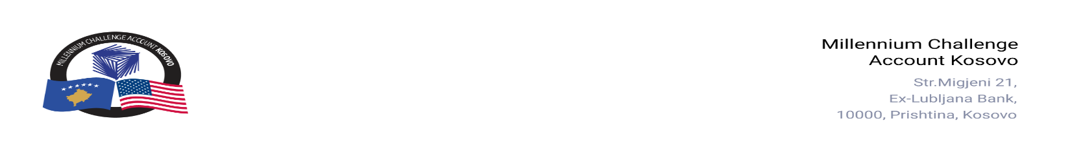

CONTRACT AWARD NOTICE

Country | : | Kosovo
City/Locality | : | Prishtina
Funding Agency | : | Millennium Challenge Corporation
Buyer | : | Millennium Challenge Account – Kosovo
Period | : | November, 2025

In line with the MCC Accountable Entity Procurement Policy and Guidelines, MCA-Kosovo publishes contract award notices to ensure transparency. Notices are posted at least monthly on the Accountable Entity website and include all contracts signed within the previous 30 days, including those awarded through Limited Bidding, Direct Contracting, and Sole Source Selection.
The following contracts were awarded during the period of November 2025:

Goods, Works and Non-Consultant Services
Number and Name of the Procurement | Selected Offeror | Contract Amount | Contract Period | Scope of the Contract
25-3008  CASCO Insurance for MCA-Kosovo Vehicles | Kompania e Sigurimeve te pergjitheshme Siguria Sh.A | EUR 1,564.67  (One Thousand Five Hundred Sixty-Four Euros and Sixty-Seven Cents). | November 1- 30, 2025. | Annual Insurance coverage for the MCA Kosovo cars.
25-1006  Safe Box for MCA Kosovo | PROTEC SH.P.K. | EUR 690.00  (Six Hundred Ninety Euros) | From November 12, 2025  Delivery up to six (6) working days from the date of signing the Purchase Order. | Supply and delivery of a safe box.
25-2001  Medium Voltage Line Dislocation | ABN GROUP SH.P.K. | EUR 46,717.20  (Forty-Six Thousand Seven Hundred Seventeen Euros and Twenty Cents) | From November 13, 2025.  Completion: Thirty (30) calendar days from the Start Date. | Execution of small works related to the dislocation of the medium voltage line, including supply, transportation, installation, and commissioning of all required materials and components in accordance with KEDS’ specifications and standards.
25-1001  First aid kit for MCA Kosovo office needs | Maliq Buzuku B.I. | EUR 2,063.76  (Two Thousand Sixty-Three Euros and Seventy-Six Cents) | From November 26, 2025.  Delivery: Five (5) working days from the date of signing the Purchase Order. | First aid kit for MCA Kosovo office.
25-3003  Bank Agreement | Procredit Bank Sh.A | Not applicable. | From November 19, 2025, up to 12 months with automatic extension for successive one (1) year periods (not to exceed six (6) such consecutive periods). | Banking Services.

Consultant Services
Number and Name of the Procurement | Selected Offeror | Contract Amount | Contract Period | Scope of the Contract
25-4004  Fidic and Contract Management Expert | Mark Etheridge | USD 10,073.00  (Ten Thousand Seventy-Three Dollars) | November 24-December 30, 2025. | Provide surge support to MCA-Kosovo for the rapid preparation of project management structures under FIDIC contracts.

