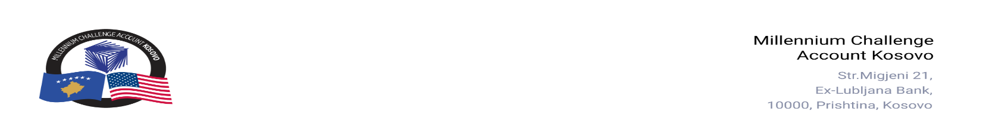

CONTRACT AWARD NOTICE

Country | : | Kosovo
City/Locality | : | Prishtina
Funding Agency | : | Millennium Challenge Corporation
Buyer | : | Millennium Challenge Account – Kosovo
Period | : | September - October, 2025

In line with the MCC Accountable Entity Procurement Policy and Guidelines, MCA-Kosovo publishes contract award notices to ensure transparency. Notices are posted at least monthly on the Accountable Entity website and include all contracts signed within the previous 30 days, including those awarded through Limited Bidding, Direct Contracting, and Sole Source Selection.
The following contracts were awarded during the period of September - October 2025:

Goods and Non-Consultant Services
Number and Name of the Procurement | Selected Offeror | Contract Amount | Contract Period | Scope of the goods/Non-Consultant Services
25-3007  FIDIC Yellow Book Training | Contract Solutions | US$ 11,954.00  (Eleven Thousand Nine Hundred Fifty-Four US Dollars). | Contract signed on: October 14, 2025. Contract duration: six (6) months, with a level of effort of three (3) working days. | Provision of a 3-day training to MCA-Kosovo staff applying the FIDIC Conditions of Contract.
25-1005  Indoor plants for MCA-Kosovo Office | N.T.P. “LULISHTJA BUÇAJ | EUR 1,176.20  (One Thousand One Hundred Seventy-Six Dollars and Twenty Cents) | Purchase Order signed: October 13, 2025.  Delivery: Three (3) days. | Supply and delivery of indoor plants for MCA-Kosovo office.
25-3005  Event Planning and Management Services | - Red Mill L.L.C.  - Pi Communication L.L.C. | Blanket Purchase Agreements (BPA) | BPAs signed on: October 28, 2025.  BPA duration: One (1) year from the signature date, with the possibility of extension for additional one-year option periods up to April 30, 2029. | Event planning and management services for MCA-Kosovo, including the organization and coordination of official events, conferences, and outreach activities, as requested through individual Service Orders.

Consultant Services
Number and Name of the Procurement | Selected Offeror | Contract Amount | Contract Period | Scope of the Services
24-4005  Recruitment Firm for the Energy Storage Corporation (ESCorp) employees. | The Headhunter Karriera LLC (Lead), in association with Impact Assessment Institute shpk (Partner 1) | EUR 200,000.00  (Two Hundred Thousand Euro) | Contract signed on: October 16, 2025.  Duration Base Period: 10 months  Duration Option Period: 6 months. | The main objective of the assignment is to manage the recruitment process for the ESCorp as directed by MCA-Kosovo.
24-4010  External Legal Services for MCA Kosovo | RPHS Law L.L.C | Blanket Purchase Agreement (BPA) | BPA signed on: October 28, 2025  BPA duration: 12 months. | External Legal Services for MCA-Kosovo
24-4003  Implementation of JETA Energy Skills for the Future Activity | IBF Expertise S.A. (Lead) in Association with European Projects Management Ltd (SIA Eiropas projektu vadība) (Partner 1) and Dansk Energi Management af 2024 ApS (Partner 2). | USD 970,450.00  (Nine Hundred Seventy Thousand Four Hundred Fifty USD). | Contract signed on: October 23, 2025.  Base Period duration: 12 months. | The selected offeror will work closely with MCA-Kosovo and stakeholders to review, enhance, and finalize the Energy Skills for Future (ESF) Activity Design and initiate its implementation based on the approved design. Main deliverables include completing the ESF Detailed Design Report, the Implementation Plan, the CESI Business Plan, and the Infrastructure and Equipment Report. In addition, the offeror will support the development of CESI’s governance structure, as well as the regulations, operational procedures, policies, and procedures needed to implement and manage CESI effectively.

Note: Blanket Purchase Agreements (BPAs) are not contracts but agreements to contract. The contract occurs when an order is placed. Thus, there are no binding terms on either party.

