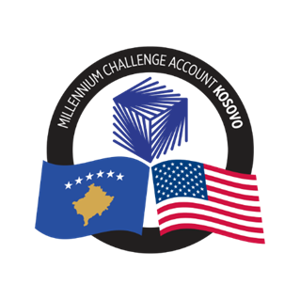

GENERAL PROCUREMENT NOTICE (GPN)

Government of the Republic of Kosovo

Millennium Challenge Account - Kosovo

GPN Version: 2025-KOS-GPN-001

GPN Publication Date: September 2, 2025

The Government of the Republic of Kosovo (the “Government” or “GoK”) has received grant funding of Two Hundred Two Million United States Dollars (US $202,000,000) from the Millennium Challenge Corporation (MCC) of the United States Government and a corresponding contribution from the Government of Kosovo of approximately Thirty-Four Million Six Hundred Seventy Thousand Six Hundred United States Dollars (US$ 34,670,600) to enable the Government of Kosovo to implement this program and achieve the objectives of the MCC Grant (compact), and it intends to apply parts of the proceeds of the funds to payments for contracts for goods, works and services.

The Government has designated the Millennium Challenge Account Kosovo (MCA-Kosovo) to implement the Government’s responsibilities under the Agreement and intends to apply part of the funds to payments for contracts for Goods, Works and Services.

The updated procurement plan for the 12-month period from September 2025 to August 2026 and will include the following:

Procurements for September 2025 to August 2026
Estimated Value – USD 1,967,860.66
Procurement of Consultant Services:
- Ministry of Environment, Spatial Planning, and Infrastructure (MESPI) greenhouse gas Inventory Technical Assistance
- Design-Supervision for infrastructure works in University of Prishtina
- Individual consultants for Offeror Review Panels for Procurement and Selection Committee for Grants
Procurement of Goods:
- Office maintenance tools
- Safe for MCA Kosovo
- KOSTT PIU Personal protection equipment
- Personal protection equipment for MCA Kosovo Staff
- Microclimate and electrical measuring devices for MCA Kosovo office
- First aid kit for MCA Kosovo office needs
Procurement of Works
- Medium Voltage Line Dislocation
Procurement of Non-consultant Services:
- Insurance for KOSTT vehicle
- Fire safety measures for MCA Kosovo office
- Translation Services
- Multimedia and Social Media Services
- Event Planning & Management Services
- Comprehensive Training on BESS

Updated GPNs shall be published as new procurements are added.

Contracts for Goods, Works and Services financed under the program will be implemented according to the principles, rules and procedures set out in the MCC Procurement Policy and Guidelines (PPG) which can be accessed on www.mcc.gov/ppg. The Procurement is open to all offerors from eligible source countries as defined in the MCC PPG.

Specific procurement notices for contracts to be tendered under competitive bidding procedures will be announced, as they become available, on Development Gateway Market (dgMarket: http://www.dgmarket.com/), in local newspapers, and other media outlets as appropriate and at the MCA-Kosovo website (mcakosovo.org).

Interested eligible offerors wishing to receive procurement advertisements or request additional information should email the Procurement Agent at mcakosovopa@dt-global.com with the subject line “2025-KOS-GPN-001” specifying the procurement items of interest. Alternatively, interested parties may register directly via the following link: https://forms.office.com/r/JuW255gYUf .

