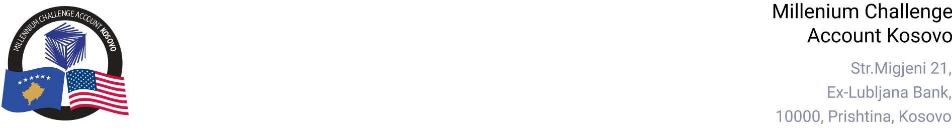

MCA-KOSOVO

CONTRACT AWARD NOTICE

Country | : | Kosovo
City/Locality | : | Prishtina
Funding Agency | : | Millennium Challenge Corporation
Buyer | : | Millennium Challenge Account – Kosovo
Period | : | January - August 2025

In line with the MCC Accountable Entity Program Policy and Guidelines, MCA-Kosovo publishes contract award notices to ensure transparency. Notices are posted at least monthly on the Accountable Entity website and include all contracts signed within the previous 30 days, including those awarded through Limited Bidding, Direct Contracting, and Sole Source Selection.
The following contracts were awarded between January and August 2025:

Goods and Non-Consultant Services
Number and Name of the Procurement | Selected Offeror | Contract Amount | Contract Period | Scope of the goods/Non-Consultant Services
24-3020  Redesign and Maintenance of MCA Kosovo Website | CLLEANCODE L.L.C. | 36,600.00 Euro  (Thirty-six Thousand Six Hundred Euro) | - Base Period: 14 months from January 8, 2025.  - Option Periods 1-3: 12 months each.  - Option Period 4: From end of Option Period 3 to April 29, 2029. | Redesign, Migration and Maintenance of the MCA-Kosovo Website.
25-3002  Office Cleaning services for MCA Kosovo | MSS Mobile Sanitary Services SH.P.K. | Blanket Purchase Agreement | - Base period: Two (2) months from March 8, 2025.  - Option Periods: 1-3: Twelve (12) months each.  - Option Period 4: Eleven (11) months and fourteen (14) days. | Office Cleaning services for MCA Kosovo.

Note: Blanket Purchase Agreements (BPAs) are not contracts but agreements to contract. The contract occurs when an order is placed. Thus, there are no binding terms on either party.

