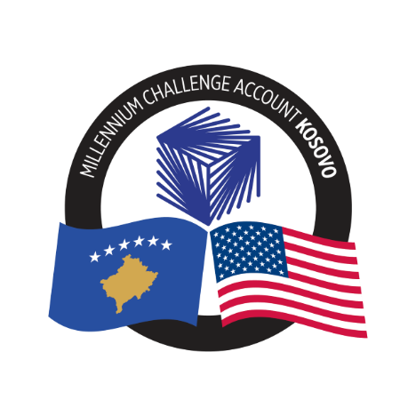

Minutes of Pre-Offer Conference

Procurement of Consultant Services

Recruitment Firm for Energy Storage Corporation (ESCorp) employees
Ref. No.: 24-4005

September 30, 2024

Date: September 27, 2024, at: 14:00 hrs (Kosovo local time)
- Attendance (online via Teams)

From MCA-Kosovo
- Drilon Potera - Procurement Director, MCA-Kosovo
- Ymer Rudari- Manager of Multi-Functional Energy Storage, MCA-Kosovo
- Bajram Neshati- Project Director for Energy Storage Project, MCA-Kosovo
- Adem Hajdini- MFES Technical Specialist, MCA-Kosovo
- Patricia Sanchez – Manager, Procurement Agent (PA)
- Afrim Bajrami - Senior Procurement Specialist, Procurement Agent (PA)
- Nazmi Gervalla - Procurement Specialist, Procurement Agent (PA)
From the Participants:

- 17 persons were connected from different organisations.
B. Introduction & Opening Remarks
The MCA-K Procurement Director (PD) opened the Pre-Offer Conference at 14:00 hrs, as scheduled, by welcoming all attendees and informing the agenda of the meeting followed by the presentations from the MCA-K Project Team. The PD summarized the important dates for this procurement as planned in the RFO, as well as a brief presentation of the project. It was informed to all attendees that responses to questions will be addressed after all presentations were completed.

The attendees were informed that the meeting was going to be recorded for the preparation of the minutes, and the same will be sent to all the attendees and to those Offerors who had registered with the Procurement Agent. This will also be uploaded to MCA-K website.
C. Presentation of the Scope of Services and the RFO
- Project and Scope of Services Presentation.
Mr. Ymer Rudari, MCA-K Manager of Multi-Functional Energy Storage, provided the overview of the Multi-Functional Energy Storage Activity, the main activities, objective and specific description of the scope of work, the base and the option periods.
- Procurement Procedures Presentation
The Procurement Agent explained the key contents of the RFO and the procurement process, emphasizing that the firms should download the relevant parts of the RFO: i.e.: Section I, "Instructions to Offerors", Section VI- General Conditions of and Section VIII, Contract Forms and Annexes for a complete understanding of the requirements of the RFO. The Procurement Agent reminded the attendees of the deadline for submission of questions, noting that these should be submitted in writing to the email provided in the RFO document.

D. Questions and Answers
At the end of the Presentation, the MCA-K PD, proceeded to read all the questions which were written in the chat from some Offerors and some answers were provided by MCA-K and the PA Team. Below are the questions raised during the meeting.
Question 1: | Is there any time frame of implementation set or is it left for the to the bidder to determine?
Answer 1: | There is a government administrative instruction for hiring the officials for the POEs (Public Owned Enterprises). The deadlines need to be reflected in the offer and should be in line with the Terms of Reference, which provides the required timeline. These need to be followed in order to comply with the law. The administrative instruction on hiring the POEs members is crucial in this process.

Question 2. | With regards to the team composition: What is an industry recruitment specialist – please clarify the difference from Team Leader and Candidate Sourcing Specialist?
Answer 2: | The requirements for all positions are indicated within the RFO, Section III, Qualification and Evaluation Criteria.

Question 3: | Will the presentation slides be shared to us?
Answer 3: | The presentation file as well as the direct link to the recording of the meeting will be shared with everyone and will be made public on the MCA website.

Question 4: | Would you be able to share the various tech forms word format?
Answer 4: | The Forms are already available in word format in the pcloud link which you have access once you have registered through the Form available in the Specific Procurement Notice. If you do not have access, the Procurement Agent can also send it by e-mail. Please, write to the email: MCAKosovoPA@dt-global.com, and request the forms.

Question 5: | Experience of Local bidders working with MCC is limited. How can this influence the evaluation of the bid if the bidder did not work before with MCC/MCA?
Answer 5: | Please note, that MCA or MCC previous experience is not mandatory and there is no additional score for that experience.  The Offeror’s experience information must be provided in TECH-4 (MCA related and/or non-MCA related experience) for each relevant assignment following the instructions described within.  In TECH-5, the Offerors will complete the information of any MCA/MCC related experience. If the Offeror does not have this experience just indicate with “Not Applicable”.  In addition, the information provided in TECH-4 and TECH-5 (if applicable) will be part of the reference check which will be conducted by the Procurement Agent.

E. Closing Remarks
- The Procurement Director of MCA-K thanked all the attendees for their participation and informed that the minutes of the pre-offer conference will be sent by email including the recording of the session and will also be uploaded to the MCA website.
- The Pre-Offer Conference concluded at 15:36 hrs (Prishtina time).

Attachments:
Annex 1 | Meeting recording | http://e.pc.cd/c6jy6alK
Annex 2 | Attendance record of the participants (online) | http://e.pc.cd/c6jy6alK
Annex 3 | Power Point presentation | http://e.pc.cd/c6jy6alK

Final Note: These answers were provided during the pre-offer conference; however, MCA-Kosovo may provide updated versions of the answers through the Clarification No. 1.

