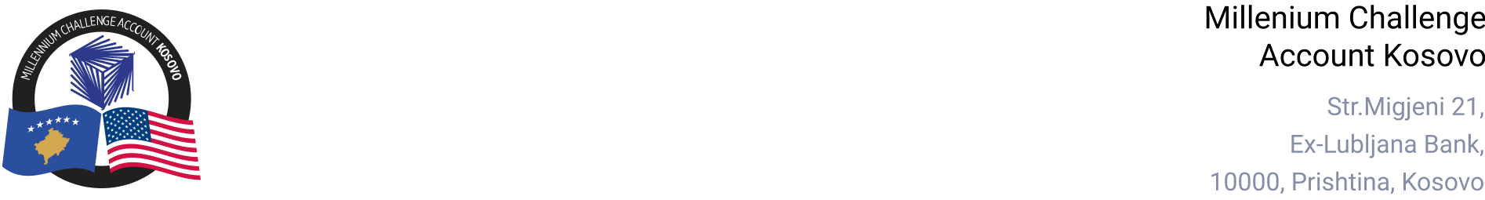

MCA-KOSOVO

CONTRACT AWARD NOTICE

Country | : | Kosovo
City/Locality | : | Prishtina
Funding Agency | : | Millennium Challenge Corporation
Buyer | : | Millennium Challenge Account – Kosovo
Period | : | December 2024

To promote transparency and in accordance with the MCC Accountable Entity Program Policy and Guidelines, MCA-Kosovo publishes the contracts award notice. A notice must be published at least monthly on the Accountable Entity website and identify the contracts signed within the last 30 days including contracts awarded by Limited Bidding, Direct Contracting and Sole Source Selection procedures.

The following contract was awarded in December 2024.

Consultant Services
Number and Name of the Procurement | Selected Offeror | Contract Amount | Contract Period | Scope of the Services
RFO/QCBS/24-4004  Audit Services for MCA-Kosovo | NEXIA Kosova Audit LLC | EUR 321,662.37  (Three Hundred Twenty-One Thousand, Six Hundred Sixty-Two Euros and Thirty-Seven cents). | Sixty-eight (68) months.  One Base Period and five Option Periods. All periods are of 12 months, except for Option Period 5, which is 8 months (includes the Closure period). | Audit Services for MCA-Kosovo during the compact period including the closure period

