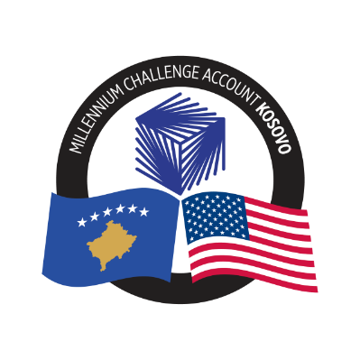
MCA-KOSOVO

CONTRACT AWARD NOTICE

Country | : | Kosovo
City/Locality | : | Prishtina
Funding Agency | : | Millennium Challenge Corporation
Buyer | : | Millennium Challenge Account – Kosovo
Period | : | September 2024

To promote transparency and in accordance with the MCC Accountable Entity Program Policy and Guidelines, MCA-Kosovo publishes the contract awards notice. A notice must be published at least monthly on the Accountable Entity website and identify the contracts signed within the last 30 days including contracts awarded by Limited Bidding, Direct Contracting and Sole Source Selection procedures.

The following contracts has been awarded during the period of September 2024.

Goods and Non-Consultant Services
Number and Name of the Procurement | Selected Offeror | Contract Amount | Contract Period | Scope of the goods/Non-Consultant Services
24-1010  Mobile workstations for MCA-Kosovo | Storm ICT L.L.C. | €10,735.00 (Ten Thousand, Seven Hundred Thirty-Five Euros) | Signed on September 24, 2024.  Delivery period 30 days from the issuance of the contract. | Supply and delivery of Mobile workstations for MCA-Kosovo, including high-end laptops, mid-range laptops, and external monitors.
24-1006(a)  Printing of promotional materials for MCA-Kosovo | Digi Print SH.P.K. | Blanket Purchase Agreement | The Blanket Purchase Agreement (BPA) will have a duration of two (2) Years or before when the maximum amount is spent | Supply and printing of promotional materials for MCA-Kosovo, as needed, based on the unit prices included in the Blanket Purchase Agreement (BPA).
24-1006(b)  Printing of promotional materials for MCA-Kosovo | TRG L.L.C. | Blanket Purchase Agreement | The Blanket Purchase Agreement (BPA) will have a duration of two (2) Years or before when the maximum amount is spent. | Supply and printing of promotional materials for MCA-Kosovo, as needed, based on the unit prices included in the Blanket Purchase Agreement (BPA).
24-1009  Office Furniture for KOSTT PIU | Gur Gur L.L.C. | €2,700.00 (Two Thousand, Seven Hundred Euros) | Signed on September 16, 2024.  Delivery period maximum 20 Days from the issuance of the contract. | Supply and delivery of Office Furniture for KOSTT PIU, including Office Desk and Chairs.

Note: Blanket Purchase Agreements (BPAs) are not contracts but agreements to contract. The contract occurs when an order is placed. Thus, there are no binding terms on either party.

