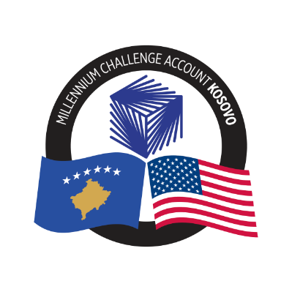
MCA-KOSOVO

CONTRACT AWARD NOTICE

Country | : | Kosovo
City/Locality | : | Prishtina
Funding Agency | : | Millennium Challenge Corporation
Buyer | : | Millennium Challenge Account – Kosovo

To promote transparency and in accordance with the MCC Accountable Entity Program Policy and Guidelines, MCA-Kosovo publishes the contract awards notice. A notice must be published at least monthly on the Accountable Entity website and identify the contracts signed within the last 30 days including contracts awarded by Limited Bidding, Direct Contracting and Sole Source Selection procedures.
The following contracts has been awarded during the period of May 2024.

Goods and Non-Consultant Services
Number and Name of the Procurement | Selected Offeror | Contract Amount | Contract Period | Scope of the goods/Non-Consultant Services
24-3004a  Translation Services | AB & Associates SH.P.K. | Blanket Purchase Agreement with the ceiling price of 25.000.00 USD | Blanket Purchase Agreement (BPA) – duration 12 months | To provide translation services to MCA-Kosovo when needed based on the unit prices included in the Offer.
24-3004b  Translation Services | Global Consulting & Development Associates SH.P.K. | Blanket Purchase Agreement with the ceiling price of 25.000.00 USD | Blanket Purchase Agreement (BPA) – duration 12 months | To provide translation services to MCA-Kosovo when needed based on the unit prices included in the Offer.
24-3004c  Translation Services | L&B Consulting L.L.C. | Blanket Purchase Agreement with the ceiling price of 25.000.00 USD | Blanket Purchase Agreement (BPA) – duration 12 months | To provide translation services to MCA-Kosovo when needed based on the unit prices included in the Offer.

