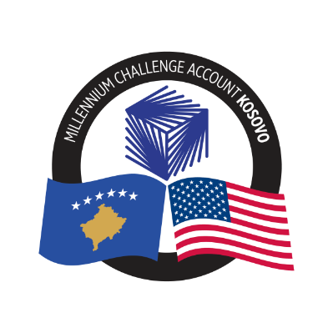
MCA-KOSOVO

CONTRACT AWARD NOTICE

Country | : | Kosovo
City/Locality | : | Prishtina
Funding Agency | : | Millennium Challenge Corporation
Buyer | : | Millennium Challenge Account – Kosovo

To promote transparency and in accordance with the MCC Accountable Entity Program Policy and Guidelines, MCA-Kosovo publishes the contract awards notice. A notice must be published at least monthly on the Accountable Entity website and identify the contracts signed within the last 30 days including contracts awarded by Limited Bidding, Direct Contracting and Sole Source Selection procedures.
The following contracts and Blanket Purchase Agreements have been awarded during the period of March 2024.

Consultant Services (Individuals)
Number and Name of the Procurement | Selected Offeror/Consultant | Contract Amount | Contract Period | Scope of the Services
23-4004(a)  Independent Reviewers for Appeals | Frederick P. Kranz | Blanket Purchase Agreement | Three (3) years with possibility of extension based on the availability of funds. | Service as an Independent Appeal Review members
23-4004(b)  Independent Reviewers for Appeals | Ahmad Gorchiyev | Blanket Purchase Agreement | Three (3) years with possibility of extension based on the availability of funds. | Service as an Independent Appeal Review members
23-4004(c)  Independent Reviewers for Appeals | Ion Josan | Blanket Purchase Agreement | Three (3) years with possibility of extension based on the availability of funds. | Service as an Independent Appeal Review members
23-4004(d)  Independent Reviewers for Appeals | Ronald Aine | Blanket Purchase Agreement | Three (3) years with possibility of extension based on the availability of funds. | Service as an Independent Appeal Review members
23-4004(e)  Independent Reviewers for Appeals | Adem Spahiu | Blanket Purchase Agreement | Three (3) years with possibility of extension based on the availability of funds. | Service as an Independent Appeal Review members

