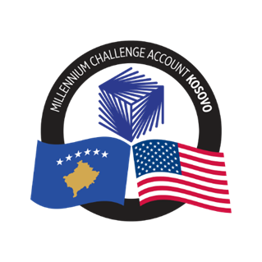
MCA-KOSOVO

CONTRACT AWARD NOTICE

Country : Kosovo
City/Locality : Prishtina
Funding Agency: Millennium Challenge Corporation
Buyer : Millennium Challenge Account - Kosovo

The following contracts have been awarded during the period of August 2023.

Consultant Services (Firms)

Number and Name of the Procurement | Selected Consultant | Contract Amount | Contract Period | Scope of the Services
23-3001  Regulation on Energy Storage Training | Energy Regulators Regional Association (ERRA) | Euro 3,885.00 (Three thousand eight hundred eighty-eight  Euro with TAX) | September 11 -19, 2023 | Introduction and system testing, Setting the scene on energy storage and its role in the energy system, market design for energy storage, grid regulation for energy storage.

Works

Number and Name of the Procurement | Selected Company | Contract Amount | Contract Period | Scope of the Works
KOS-3016  MCA Kosovo Office Space Renovation | Joint Venture ARTDEKOR DPT-Faton Maxhuni B.I.& A and F construction SHPK | Euro 553,697.81 (Five hundred and fifty-three thousand and six hundred and ninety-seven Euros and eighty-one cents) | The Intended Completion Date for the Works shall be 100 days from the Start Date | The Works consist of rehabilitation of the 8th, 9th and 10th floors together with the roof of the ex-Lubljana Bank in Pristina as per the MCA-Kosovo  requirements.

CONTRACT AMENDMENTS

Consultant Services (Firms)

Number and Name of the Procurement | Selected Consultant | Contract  Amendment Amount | Contract Period Amendment | Contract Amendment 1
KOS-3005  Procurement of HR Firm for MCA Staff Recruitment | The Headhunter Karriera LLC | Original contract: 234,900.00 Euro.  There is no modification in the contract value | Original period:  up to September 1st, 2023.  Amended period:  Up to December 31, 2023 | Extension of the contract validity period.

