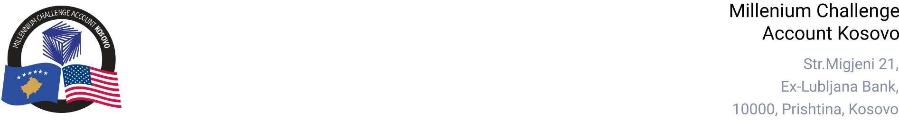

MCA-KOSOVO

CONTRACT AWARD NOTICE

Country | : | Kosovo
City/Locality | : | Prishtina
Funding Agency | : | Millennium Challenge Corporation
Buyer | : | Millennium Challenge Account – Kosovo
Period | : | November 2024

To promote transparency and in accordance with the MCC Accountable Entity Program Policy and Guidelines, MCA-Kosovo publishes the contract awards notice. A notice must be published at least monthly on the Accountable Entity website and identify the contracts signed within the last 30 days including contracts awarded by Limited Bidding, Direct Contracting and Sole Source Selection procedures.

The following contracts has been awarded during the period of November 2024.

Goods and Non-Consultant Services
Number and Name of the Procurement | Selected Offeror | Contract Amount | Contract Period | Scope of the goods/Non-Consultant Services
24-1011b  Breakroom Supplies for MCA-Kosovo | TuttoCapsule Kosova SH.P.K. | Blanket Purchase Agreement | Base Period: 12 months with three additional option periods of 12 months each. | Supply and delivery of Breakroom Supplies for MCA-Kosovo -as need based the unit prices included in the Blanket Purchase Agreement (BPA)
Consultant Services (Individuals)
Number and Name of the Procurement | Selected Offeror/Consultant | Contract Amount | Contract Period | Scope of the Services
24-4007  Consultant to facilitate passage of three laws related to the Compact Conditions Precedent | Vesa Janova | EUR 3,000.00  (Three Thousand Euros) | November 07, 2024 - January 06, 2025. | - Facilitate the passage of the Law on Electrical Energy and the Law on Energy.  - Ensure the alignment and compliance of these laws with the Clean Energy Package and other relevant legislation.  - Provide expert legal guidance to support the working groups in their due diligence processes.  - Contribute to the advancement of Kosovo's energy sector legislation in line with EU standards and MCC Compact requirements.

Note: Blanket Purchase Agreements (BPAs) are not contracts but agreements to contract. The contract occurs when an order is placed. Thus, there are no binding terms on either party.

